Name : Saurabh Sanjay Jadhav

Topic : Git fetch, pull, stash and cherry-pick

Assignment no. : 4

1. Fetch the repo from github. But it will not be available in directory.

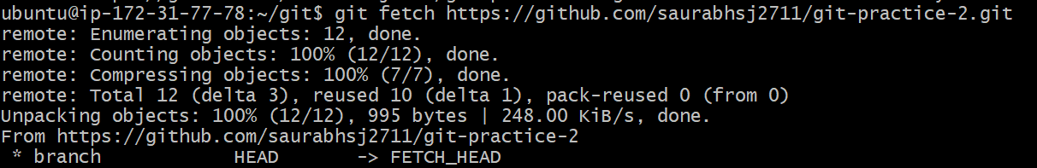

1. Use pull command to get the files in our directory.

1. Use stash command to temporarily save the uncommitted changes to another location so that we can work on other files.

Then again unstash the file using below commands:

Git stash pop

Git stash apply stash@{0}

1. Git cherry-pick
2. Create files and dir. Add and commit them to local repo. Change branch to prod.

1. Push the files to remote repo using prod.

1. Create some files and push files to remote repo using main branch.

1. Cherrypick in main branch. Copy commit id from prod branch.

